Software Requirement Specifications

for

Gaming Team Matchmaking
Version 1.0 approved
Prepared by Team: (Name TBA)
<organization>TBA
Date: 11/09/2022
Table of Contents
Table of Contents ii
Revision History ii
1. Introduction 1
1.1 Purpose 1
1.2 Intended Audience and Reading Suggestions 1
1.3 Product Scope 1
1.4 References 1
2. Overall Description 2
2.1 Product Perspective 2
2.2 Product Functions 2
2.3 User Classes and Characteristics 2
2.4 Operating Environment 2
2.5 Design and Implementation Constraints 2
2.6 Assumptions and Dependencies 3
3. External Interface Requirements 3
3.1 User Interfaces 3
3.2 Software Interfaces 3
3.3 Communications Interfaces 3
4. Analysis Models
5. System Features 4
5.1 System Feature 1 4
5.2 System Feature 2 (and so on) 4
6. Other Nonfunctional Requirements 4
6.1 Performance Requirements 4
6.2 Safety Requirements 5
6.3 Security Requirements 5
6.4 Software Quality Attributes 5
6.5 Business Rules 5
7. Other Requirements 5
Appendix A: Glossary 5
Appendix B: Field Layouts 5
Appendix C: Requirement Traceability matrix 6

Revision History
Name | Date | Reason For Changes | Version

Introduction

Purpose
This is a product that evaluates player stats to create player profiles and their scorecards over multiple criteria, and matches diverse members into compatible cross-functional teams, using python for collecting, cleaning and modeling data.

Intended Audience
This documentation contains the full work and procedure and helps track the growth and progress for the development of such a software service.
This document is primarily intended for the:
- Primary developers of the software
- Software engineers who would work on further development of the project
- The professors who will review the document
- Stakeholders, clients and tournament planners
- Maintenance crew of the services

Product Scope
The current target audience is FPS players, more importantly, competitive players, in games such as Valorant and Call of Duty: Warzone and help players find their perfect teammates with whom they can share a synchronised playstyle. This service can be further extended and modified to many other genres of multiplayer games and can be highly flexible to the type of game and its inner ranking as well.

References
- www.python.org
- https://www.geeksforgeeks.org

Overall Description

Product Perspective
The product provides services similar to the application teamtavern (https://www.teamtavern.net), with additional functionalities to create compatible cross-functional teams from the applicants and an added trust factor to ensure the team members deliver on their claims and promises.

Product Functions
The highlights of this software is to:
- Create player profiles and maintain scorecards
- Help players form better teams
- Evenly distribute talent into multi-skilled groups
- Maintain team stats
- Ensure fair play
- Let players search for other players and teams by app-generated IDs

User Classes and Characteristics
The software caters to mainly three types of players:
- Professional: The players with the higher skill level and who are very much involved in the game and are earning from the game in some form. These are priority users that require most attention as their games have higher stakes and are an opportunity for advertisement.
- Competitive: The players who grind to get to higher leagues and acquire in-game rewards and play for long sessions. These players will be the majority of the client-base and a high priority is set.
- Casual: The players who usually play for short bursts of time and are in it just to relax. These players are not necessarily going for long win streaks or reach “top fragger” position. These games don't have very high significance and hence rank lower in priority.

Operating Environment

The software is completely web based and runs on popular web browsers namely firefox, chrome, internet explorer (IE8 and above), without requiring any installations. The software will be designed to work on any version of Windows, Linux (kernel 2.7 and above) and Mac platform.

Design and Implementation Constraints
- Directly obtaining player stats from the game servers breaches their privacy policy and hence limits the automation in generating teams.
- Database used will be SQL server acquired from registrations.
- Lack of funding for better APIs

Assumptions and Dependencies
- The player using the application is assumed to have a viable in-game account and required browser specifications.

External Interface Requirements

User Interfaces

Homepage:
- Description of the platform
- Login or sign up
- Search for a team or a player through IDs
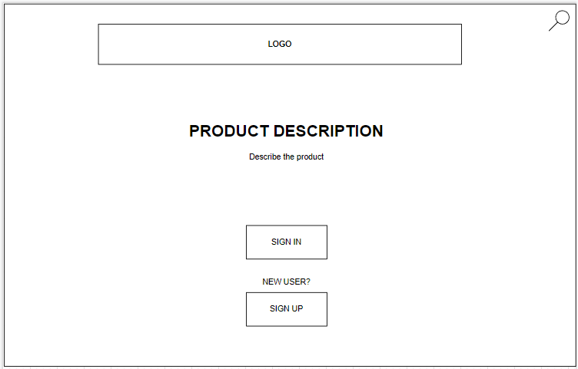

Navigation Bar:
- Go to homepage
- Go to user profile
- Search for teams and players


Sign-up page:
- Register a new player
- Collect player stats and details
- Set username and password
- Create account
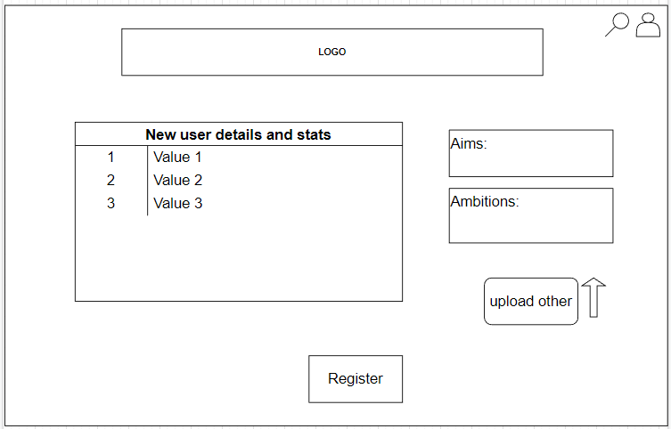

Login page:
- Take in username and password and redirect to user profile
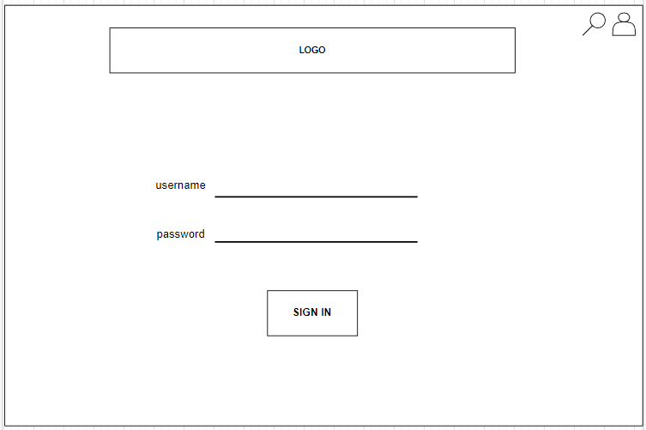

User profile:
- Display player details, stats and scorecard
- Display teams player belongs to
- Display team stats and team members
- Create teams
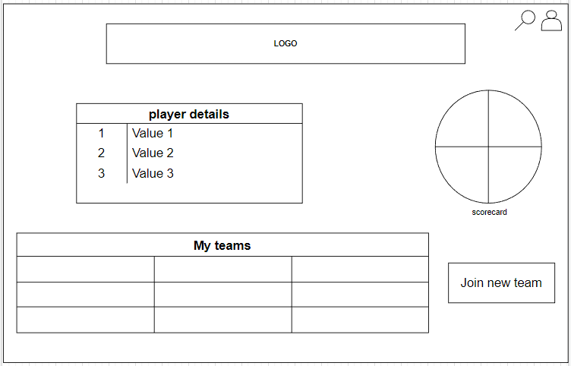

Player profiles:
- Display masked details and stats of player that matches search ID
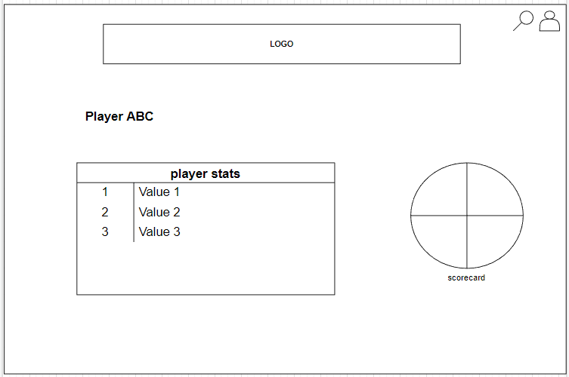

Team profiles:
- Display masked details and stats of team that matches search ID and its members
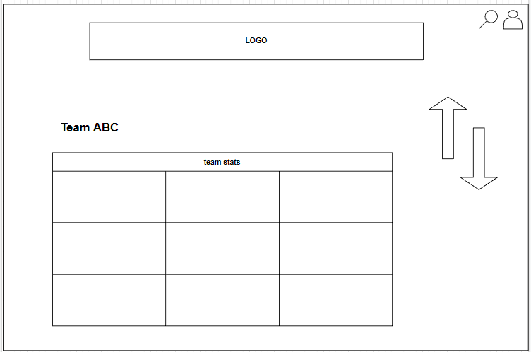

Software Interfaces
The software will be using the game-specific API to collect information accurately and compare real-time data with the data provided by the player to the service. It is also used to generate stats of players all in a convenient location, i.e. their profile.

Communications Interfaces
The software uses Django middleware to connect to the mySQL database to transfer high volume data quickly and efficiently.

Analysis Models
Use case diagram
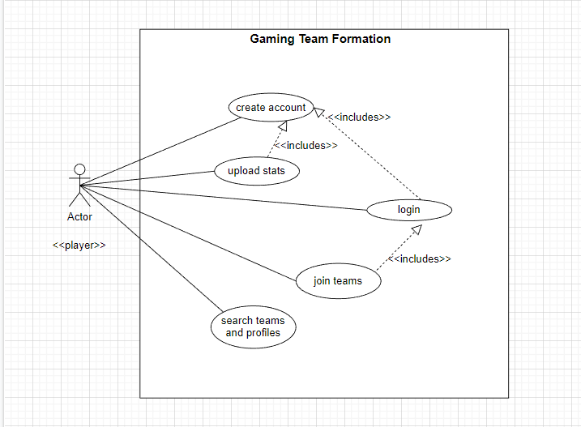

System Features

Online matchmaking
- Description and Priority:
Automatic matchmaking system to find better and compatible teammates with respective skill-sets to have a balanced experience.
- Stimulus/Response Sequence:
After the user creates their account, they can create their own teams by pressing the “Create Team” button in their profile. A user can either add a teammate normally or let the algorithm decide by providing a well-rounded team and will send a quick invite code to all of them. Once everyone accepts the invite then the match can begin.
- Functional Requirements
Scorecards is used to keep track of the team skills and hence can be used to balance every team with each players strength and weaknesses

Stats Display

- Description:
Provides a statistical list of the player’s data that include skills and win/lose ratio. This requirement is lower on the priority list as it is more of a quality of life feature.

- Stimulus/Response Sequence:
When the player logs into the application and finishes profile creation, their online stats will be displayed in their profile page

- Functional requirements:
A very beneficial quality of life upgrade that helps the player track their own performance better

Other Nonfunctional Requirements

Performance Requirements
TBD

Safety And Security Requirements
The game service will be tailored in order to give an enjoyable experience to all the users .It will be simple enough and easy to use. This app will not damage any account or statistics within the game itself. The user has to login using the secure OpenID. It will not give any personal information in the open and thus maintain users privacy and provide security.

Software Quality Attributes

The software will be built on a popular python based framework called Django, which follows Model Template View principle. Since the business logic, presentation layer and database layer are independent entities bound together by application logic it is easy to add more features in the future. Due to the MTV structure of the framework, Django, the product is easily maintainable.That is, one can avoid ripple changes throughout the entire code thus making the task of maintenance more effective and easy. The unit testing modules in python makes the task of testing better.

Other Requirements
We will be using the Valorant API for the initial game service design to better acquire data and analyse stats better. The API is documented under legal use and we have full access for us

Appendix A: Glossary
FPS : First Person Shooter
UI : User interface
MTV : Model Template View
API : Application programming Interface
OpenID : It is a decentralized single sign-on authentication system for the Internet. The goal of the OpenID initiative is to allow users to log in at websites around the Internet with one ID, instead of having to create multiple unique accounts.

Appendix B: Field Layouts
Sample sheet with information required to register the customer
Field |  | Length | Data Type | Description | Is Mandatory
Username |  | 20 | Alpha-num | Unique identification name | Y
Player ID |  | 4 | Numeric | Unique code for player | Y
Team ID |  | 4 | Numeric | Unique code for team | Y
Date of birth |  | 8 | Date | Date of birth of player | Y

Appendix C: Requirement Traceability Matrix
Sl. No | Requirement ID | Brief Description of Requirement | Architecture Reference | Design Reference | Code File Reference | Test Case ID | System Test Case ID

